CS 2830 Final Project Documentation

Zhongyu Li

Web Link: <http://xiaobentu.centralus.cloudapp.azure.com/finalproject/resume.php>

This is my personal resume page. There are six part in this website. I used HTML5, CSS, JavaScript, Php in this project.



The header section is fixed in the top of the scene. By clicking each button, the scene will switch to the correspond section. Also, the URL will change correspond to the action. I used Bootstrap for the heading bar.

Then is the My Story section. This part shows the general information about myself. This part is built by CSS, the CSS is saved in timeline.css.

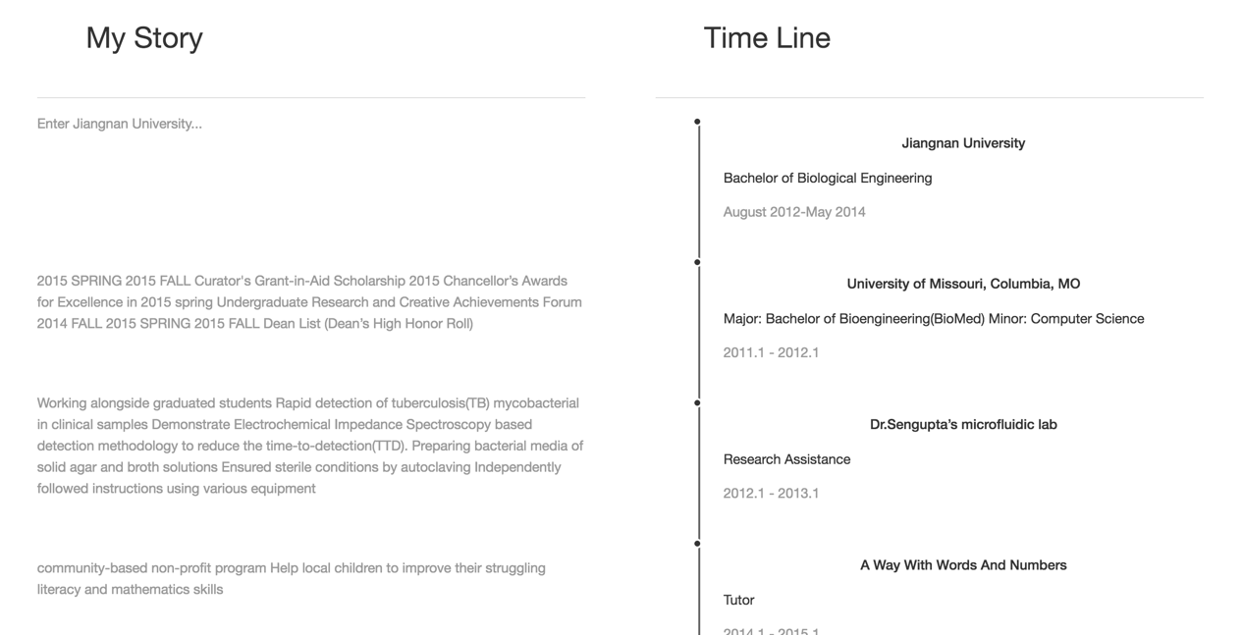

Then, it is a brief paragraph about my research. The video shows the lab I am working for. By clicking the start/pause button, you can play the video. JavaScrpt is used here.

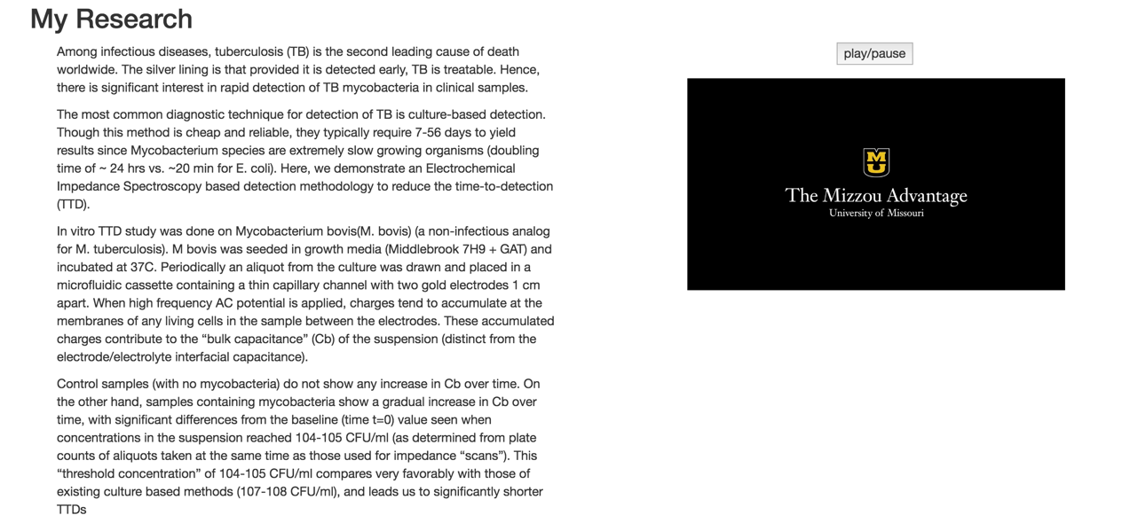

Then it is a skill bar section which show my skills. This part is also built by BootStraps.

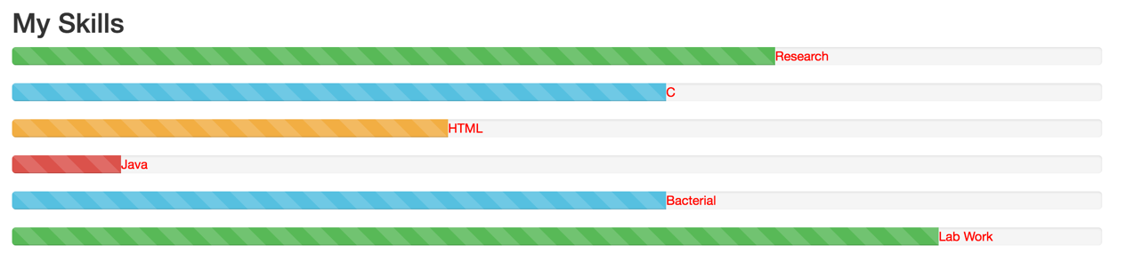

In contact me section, by filling this from, I can get the email which have information from other people. Also, the sender will get a confirm email(usually in the junk box).

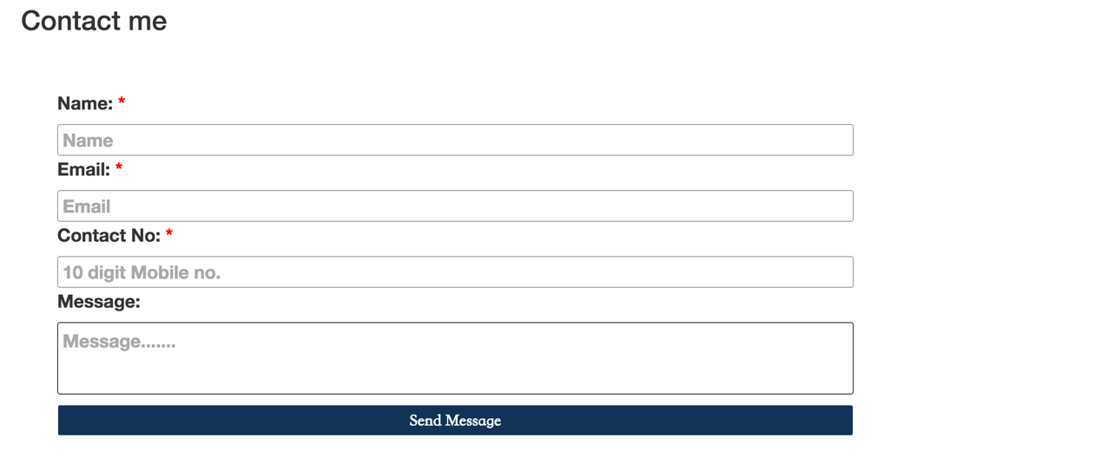

This part is my social links. By clicking the icons, people can access my social networks.

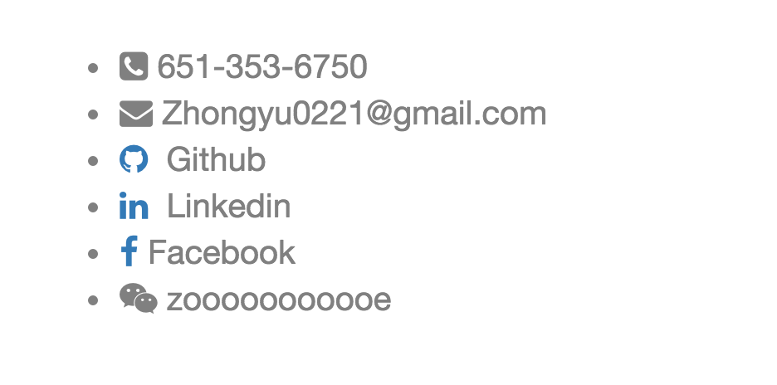

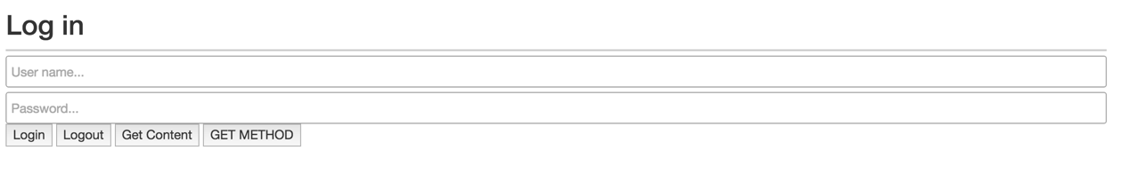

The user name and password for the log in section is set to “test” and “pass”. When the user log successfully, he or she can click the “Get Content” button to the the content which is not available for other user. When the user is not logging in or already log out, they may they must not be able to access the protected pages or functions.

I use JQuery in the contact.js. In the process.php, I use POST method to get the input username and password. If the user enters the wrong username and password, an error feedback will show. When the user successfully logs in, the protected content will show. AJAX is used here to show the content without reload the page.

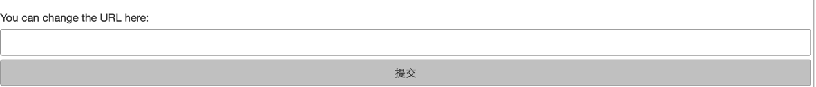

Here I use GET method to change the URL.

Here is the footer. The resume will switch to Chinese vision when clicking the link here.

../../Desktop/屏幕快照%202016-05-05%20上午8.44.48.png